DATEROEM WOOD SALES
System Documentation
System Overview and Architecture
What the Dateroem system does and how its parts fit together
Document | System Overview and Architecture
Document number | DWS-SYS-01
Version | 1.1
Date | 25 October 2026
Intended readers | Everyone - the business owner, administrators and developers
Classification | Internal - contains system design details; share only with authorised staff
The starting point of the documentation set: the business the system supports, its users and roles, the parts it is made of and how they connect, the main business flows, the technology used, and a map of the other documents.

Document control
Version | Date | Change
1.0 | 3 October 2026 | First complete edition, written from the source code as it stood on this date.
1.1 | 3 October 2026 | Added one approved phone per account (admin approval of new phones) and the fingerprint app lock.
1.1 | 4 October 2026 | Features table: Featured campaigns, sign-in options and search in lists.
1.1 | 5 October 2026 | Roles: one SuperAdmin who approves phones and computers and corrects usernames; desktop sign-in on approved computers, also through the public tunnel; security at a glance.
1.1 | 7 October 2026 | Features table: frequently asked questions on the Help page; emailing the support team from the Help and Bulk Orders pages.
1.1 | 9 October 2026 | Features: retiring a product; the phone app is for staff only.
1.1 | 9 October 2026 | Features: bulk order pictures on the Bulk Orders page.
1.1 | 10 October 2026 | Features: product and campaign photos and videos chosen on the computer in the desktop app.
1.1 | 17 October 2026 | Features: phone numbers confirmed by an SMS code.
1.1 | 18 October 2026 | Features: calm error messages and the maintenance page.
1.1 | 25 October 2026 | Since 25 October 2026 the system runs on the HostAfrica Kenya VPS C2 at https://dateroemwoods.co.ke (server name server.dateroemwoods.co.ke: Ubuntu 24.04, 1 processor, 2 GB memory with a 2 GB swap file, 50 GB disk, Nairobi time); this company computer is now where the system is developed and tested.
Keep this document up to date: when a feature, setting or server changes, edit the matching section here and add a line to the table above.
Contents
1 Introduction 3
1.1 What the system does 3
2 Users and roles 4
3 The parts of the system 5
3.1 Why one backend with three small servers 6
3.2 External services 6
4 Main business flows 7
4.1 A buying trip 7
4.2 A customer order 8
4.3 Money 9
5 Features by application 10
6 Security at a glance 12
7 Folder layout 13
8 Documentation map 14
9 Glossary 15

1 Introduction
Dateroem Wood Sales is a timber business. It buys trees from farmers on buying trips, has them sawn and finished, sells wood products - poles, sawn timber and boards, hardwood, furniture templates and decor pieces - and delivers them to customers across Kenya. The Dateroem system runs this whole cycle: what was bought and from whom, what each trip cost and earned, what is for sale, who ordered what, how it is delivered and how every shilling moved.

1.1 What the system does
- Sells products online through a customer website with M-Pesa payment, order tracking, ratings and an AI shopping assistant.
- Gives field staff a mobile app to register trees and farmers, record expenses, manage products and campaigns, run trips and deliveries, and collect or send M-Pesa payments.
- Gives administrators a desktop app to oversee everything, manage users, moderate reviews, browse the database and start or stop the system.
- Calculates each trip's income, expenses and profit automatically, and matches incoming M-Pesa payments to what they paid for.

2 Users and roles
Role | Uses | Can do
Customer | Website | Browse, ask the assistant, buy and pay by M-Pesa, follow deliveries, rate delivered products
Marketer | Mobile app | Marketing campaigns and bulk orders
ProductStaff | Mobile app | Products, trees and bulk orders
Worker | Mobile app | Trees, products, bulk orders and trip expenses (not marketing, transactions, trips list or loans)
Manager | Mobile app | Day-to-day work: orders, deliveries, trips, trees, products, expenses, bulk orders, marketing, STK push
Admin | Mobile app, desktop app | Everything above plus paying, assigning payments, refunds, loans and capital, profit, bins
SuperAdmin | Mobile app, desktop app | Everything an Admin has, plus approving and blocking staff phones and desktop computers. and correcting usernames. Exactly one account (sadmin); the role moves only when the SuperAdmin hands it over
Table 1: Roles (an older "Employee" role is retired)

3 The parts of the system
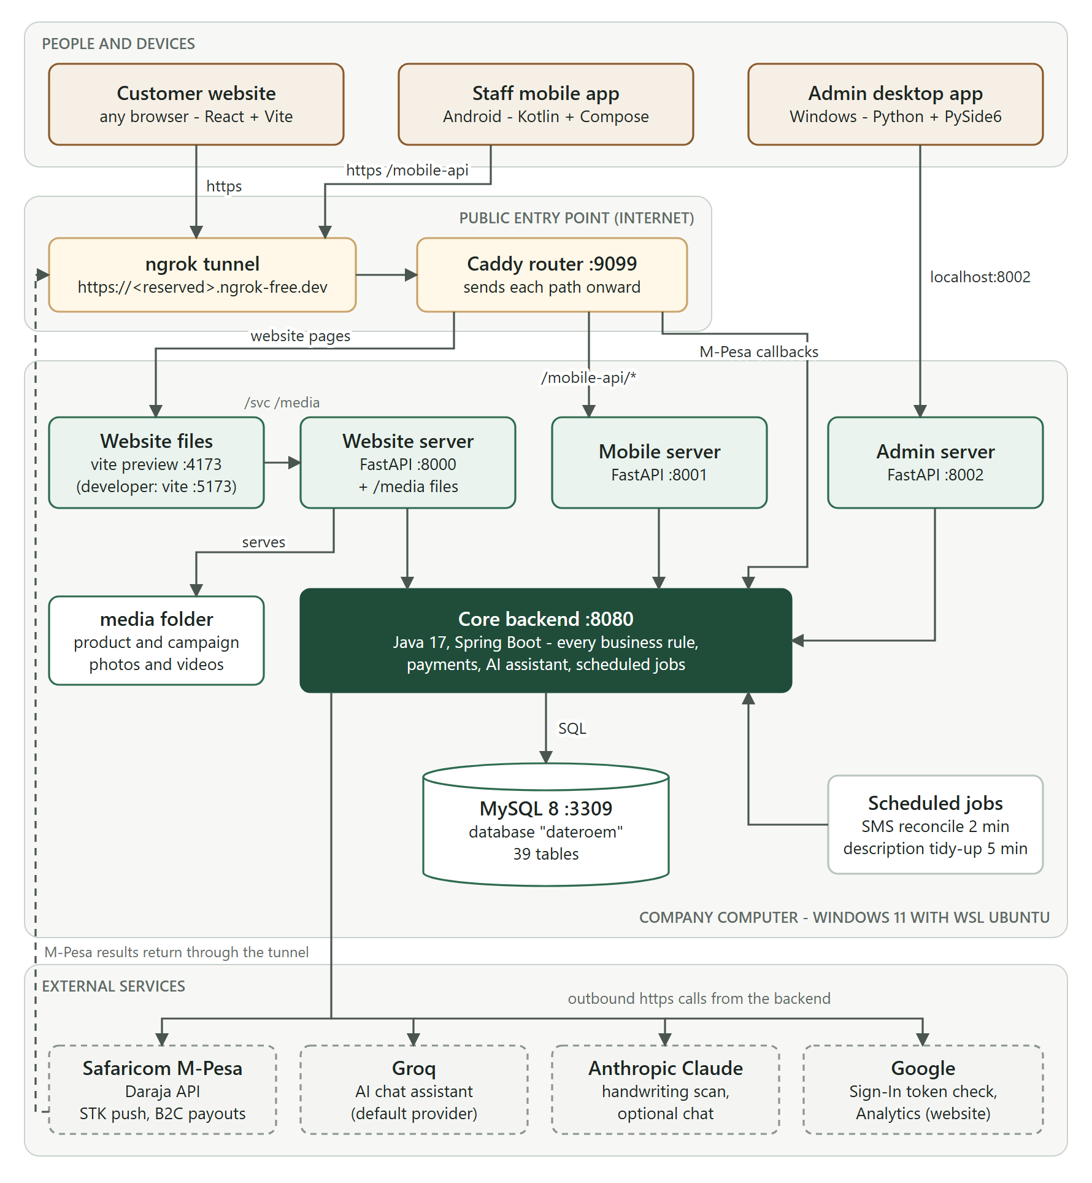
Figure 1: System architecture
Three client applications each talk to their own small server - a "backend for frontend" (BFF) shaped for that client. All three servers forward to one core backend, the only part that holds business rules, reads and writes the database, and calls M-Pesa and the AI providers. Everything runs on one company computer (Windows with Ubuntu in WSL). One public address, an ngrok tunnel leading to the Caddy router, lets customers, admins in other places and Safaricom reach the parts that must be public.
Part | Technology | Port | Location | Document
Customer website | React 18, Vite 5 | 5173 / 4173 | frontend/website | DWS-WEB-02
Website server | Python, FastAPI | 8000 | frontend/app | DWS-WEB-01
Staff mobile app | Kotlin, Jetpack Compose | - | C:\Users\PC\AndroidStudioProjects\DateroemWoodSales | DWS-MOB-02
Mobile server | Python, FastAPI | 8001 | mobileServer | DWS-MOB-01
Desktop admin app | Python, PySide6 (Qt) | - | admin_server_control/desktop | DWS-DSK-02
Admin server | Python, FastAPI | 8002 | admin_server_control/server | DWS-DSK-01
Core backend | Java 17, Spring Boot 3.2 | 8080 | backend | DWS-BE-01
Database | MySQL 8.0 | 3309 | WSL Ubuntu; scripts in "sql scripts" | DWS-BE-02
Public router | Caddy | 9099 | Caddyfile | DWS-OPS-01
Public tunnel | ngrok (Windows) | 4040 status | Windows | DWS-OPS-01
Table 2: System components (paths are inside /root/fathersProject unless stated)

3.1 Why one backend with three small servers
- Business rules exist once, in the backend, so the website, the app and the desktop always agree.
- Each client gets responses shaped for it (image addresses that work on that client, upload handling for phones, smaller trip lists at busy times) without changing the backend.
- The backend and database are never exposed to the internet; only the router's chosen paths are.

3.2 External services
Service | Used for | Document
Safaricom M-Pesa (Daraja) | STK push payments, Send Money (B2C) payouts, payment results | DWS-BE-03
Groq | AI chat assistant (free tier, default) | DWS-BE-04
Anthropic (Claude) | Reading photographed handwritten production sheets; optional chat | DWS-BE-04
Google | Sign in with Google; Google Analytics on the website (with consent) | DWS-WEB-02
ngrok | The public HTTPS address | DWS-OPS-01

4 Main business flows

4.1 A buying trip
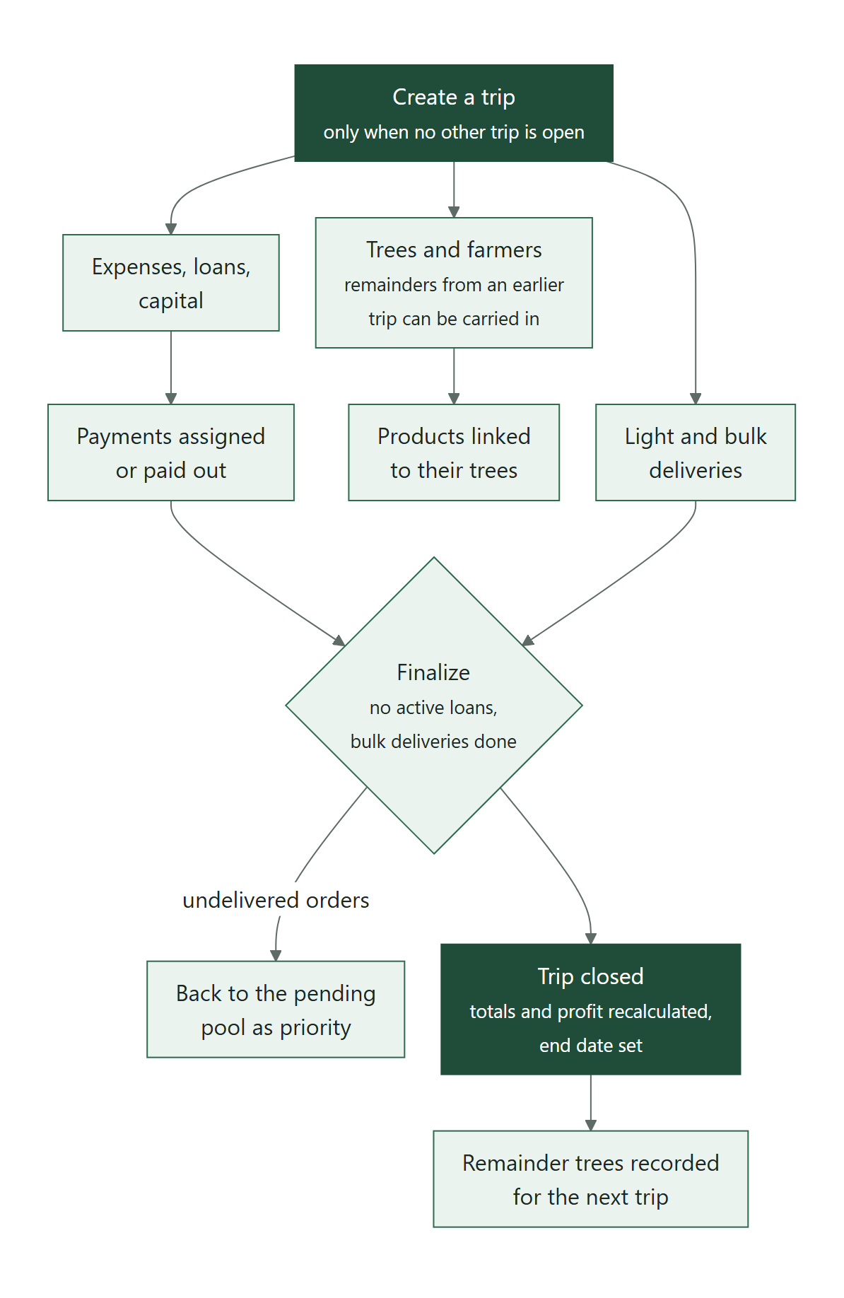
Figure 2: From creating a trip to its profit
Everything operational hangs off a trip: tree registrations and farmer payments, expenses, loans and capital, and the deliveries made during it. Only one trip is open at a time. Finalizing it requires loans to be settled and bulk deliveries finished; undelivered orders return to the pending pool as priority, and the profit is calculated.

4.2 A customer order
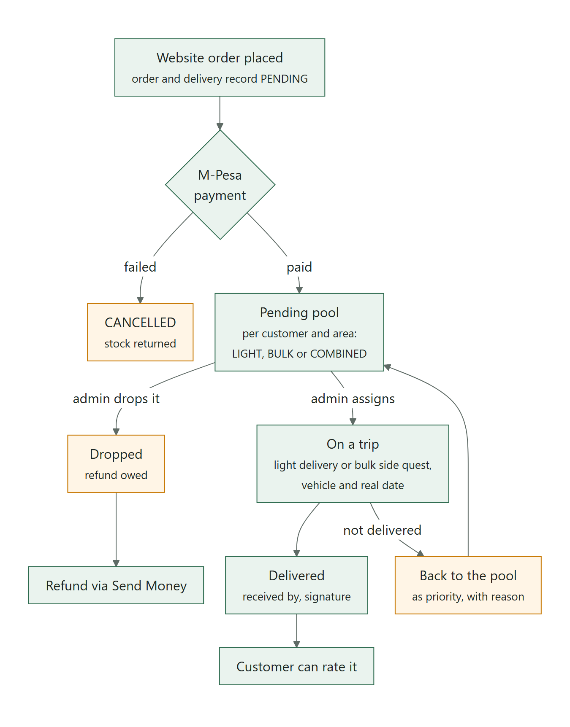
Figure 3: From a website order to delivery and rating

4.3 Money
- Money in: customers pay website orders by STK push; staff send STK pushes for bulk goods; offline payments are read from M-Pesa SMS on the company phone.
- Money out: admins pay expense entries, loan repayments and refunds with Send Money (B2C), after a bold confirmation step.
- Matching: every payment becomes a transaction that an admin assigns to the entry it paid for; trip profit is recalculated when that happens.

The M-Pesa Payments document (DWS-BE-03) describes these flows in detail, including the switch from the sandbox to real money.

5 Features by application
Feature | Website | Mobile app | Desktop app
Browse products and reviews | Yes | Manage | Manage
Featured campaigns (only while running) | Yes | Manage, choose products | Manage, choose products
Sign in | Username or email; Google | Username or email, on an approved phone | Username or email, on an approved computer (Admin and SuperAdmin)
Search in lists | Products | Pickers | Every long list
Frequently asked questions | Help page (search, topics) | - | FAQs (add, edit, hide)
Email the support team | Email button on the Help and Bulk Orders pages opens a window to write it (no email app needed) | - | -
Buy and pay by M-Pesa | Yes | - | -
Follow orders, rate products | Yes | - | Moderate reviews
AI assistant | Shopping help | Role guidance | -
Products, campaigns (with bins) | - | Yes | Yes
Retire a product (off sale, can come back) | Disappears from the shop | Yes (admins) | Yes (admins)
Bulk order pictures | Slideshow on the Bulk Orders page | Marketing (Marketer, admins) | Marketing (admins)
Phone number confirmed by SMS | A 6-digit code at sign-up and before a first order (Airtel numbers for now) | - | Users shows when a number was confirmed
Calm error messages | Plain sentences; a "We'll be right back" page while a server is down | Plain sentences on every screen | -
Product and campaign photos and videos | Shown in the shop and on Featured | Camera or gallery | Chosen on the computer (since 10 October 2026)
Trees, farmers, remainder trees | - | Yes | Yes (in trips)
Trips and finalization | - | Yes | Yes
Orders to deliveries, delivery signatures | - | Yes | Yes (no signature)
Expenses | - | Yes | Yes
STK push, Send Money, assign, refunds | - | Yes | Yes
Loans and capital | - | Admins | Yes
Company-SIM SMS reading | - | Company phone | -
Voice form filling | - | Yes | Yes
Users, delivery areas, machines, vehicles | - | Delivery areas | Yes
Database browser, server control | - | - | Yes
One approved phone per account, fingerprint lock | - | Yes | Approve phones

6 Security at a glance
- Passwords are stored as BCrypt hashes; sign-in returns a signed token valid for 30 days (12 hours for the desktop app).
- Customers see only their own orders, with their own order numbers instead of internal ids.
- Only the website, the mobile app path, the desktop app path (approved computers only), APK downloads and the M-Pesa callback are public.
- Staff use the mobile app on one approved phone per account: the phone proves itself with a key held in its secure hardware, new phones wait for the SuperAdmin, and the acting user is taken from the verified sign-in. The app also asks for the fingerprint or screen lock when opened.
- Admins use the desktop app on one approved computer each: the computer proves itself with a key kept by Windows (in its TPM chip where there is one), new computers wait for the SuperAdmin, and the acting user is taken from the verified sign-in. This is what lets the desktop app work from any computer once the servers move to a provider.
- Every important change is written to an audit log with who made it.
- Open items before production - backend role checks, secret handling, HTTPS addresses for the servers - are listed in the Production Go-Live Checklist (DWS-CFG-02).

7 Folder layout
/root/fathersProject
backend/ Java backend (Spring Boot)
frontend/app/ website server (FastAPI)
frontend/website/ customer website (React + Vite)
mobileServer/ mobile server (FastAPI)
admin_server_control/
server/ admin server (FastAPI)
desktop/ desktop admin app (PySide6)
sql scripts/ schema, functions, migrations 002-030
media/ product and campaign photos and videos
downloads/ shared Android APK
db_backups/ database dumps
dateroem animations/ About page animation frames
documentation/ this documentation
Caddyfile public router configuration
business rules.txt the original business rules

C:\Users\PC\AndroidStudioProjects\DateroemWoodSales Android app
C:\Scripts launch scripts

8 Documentation map
Folder | Document | Id | Read it to
(top) | Documentation Index | DWS-IDX-00 | Find the right document
01 System Overview | System Overview and Architecture | DWS-SYS-01 | Understand the whole system
01 System Overview | Development Timeline | DWS-SYS-02 | See when each feature was built
02 Configuration and Production | Configuration and Secrets Reference | DWS-CFG-01 | Change any setting or key
02 Configuration and Production | Production Go-Live Checklist | DWS-CFG-02 | Prepare for real customers and money
03 Backend | Backend Server | DWS-BE-01 | Work on business rules and endpoints
03 Backend | Database | DWS-BE-02 | Understand or change the data
03 Backend | M-Pesa Payments | DWS-BE-03 | Understand payments; go live with M-Pesa
03 Backend | AI Assistant | DWS-BE-04 | Understand or tune the AI features
04 Website | Website Server (BFF) | DWS-WEB-01 | Work on the website's server
04 Website | Website User Interface | DWS-WEB-02 | Work on the website
05 Mobile | Mobile Server (BFF) | DWS-MOB-01 | Work on the app's server
05 Mobile | Mobile Application | DWS-MOB-02 | Work on, build or share the app
06 Desktop | Admin Server (BFF) | DWS-DSK-01 | Work on the desktop app's server
06 Desktop | Desktop Admin Application | DWS-DSK-02 | Use or work on the desktop app
07 Operations | Running and Operating the System | DWS-OPS-01 | Start, stop and look after the system
07 Operations | Troubleshooting Guide | DWS-OPS-02 | Fix a problem

9 Glossary
Term | Meaning
BFF | "Backend for frontend": a small server dedicated to one kind of client (website, mobile, desktop)
Trip | One buying-and-selling journey; the record every expense, tree, loan and delivery belongs to
Remainder trees | Trees bought but not used on a trip, carried to a later trip
Body feet / board feet | Timber volume measure; products can be stocked by pieces or board feet
Light delivery | Delivery of ordinary website orders, possibly several orders together
Bulk (heavy) delivery | A large order negotiated mostly offline and delivered as one load
Side quest | Light orders riding along with a bulk delivery that has space
Expense entry (holder) | A recorded expense waiting to be paid or matched to a payment
Hard cash / soft cash | Physical cash / M-Pesa (mobile) money
STK push | An M-Pesa payment prompt sent to a customer's phone (Lipa na M-Pesa Online)
B2C / Send Money | An M-Pesa payment from the business to a person
Daraja | Safaricom's M-Pesa developer API
Sandbox | Safaricom's test environment - no real money moves
Callback | Safaricom calling the system back with a payment result
JWT | The signed sign-in token every client sends with its requests
WSL | Windows Subsystem for Linux - the Ubuntu environment the servers run in
ngrok | Service giving the company computer a public HTTPS address
Caddy | The router that decides which public path goes to which server
Soft delete / bin | Records are hidden, not erased, and can be restored

